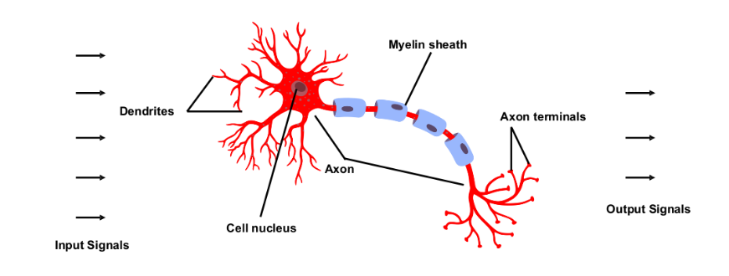

* Neurons are interconnected nerve cells that build the nervous system and transmit information throughout the body.
* Dendrites are extension of a nerve cell that receive impulses from other neurons.
* Cell nucleus stores cell’s hereditary material and coordinates cell’s activities.
* Axon is a nerve fiber that is used by neurons to transmit impulses.
* Synapse is the connection between two nerve cells.

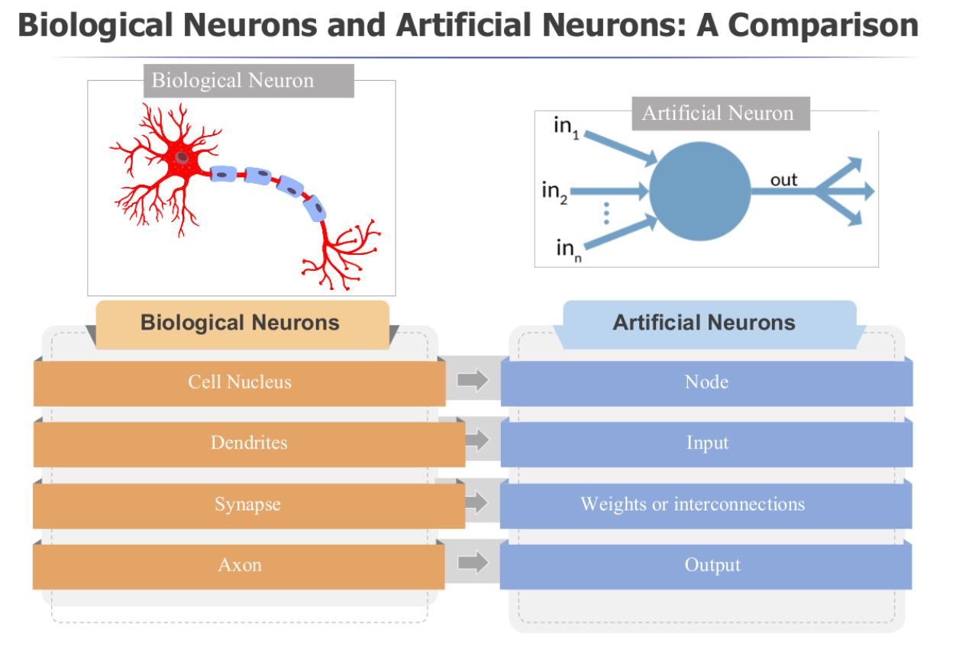

An artificial neuron takes inputs, adds weight separately, sums them up and passes this through activation function to produce a non-linear output.

* A single-layer perceptron is a type of neural network that consists of only one layer of output nodes.
* A neuron takes a weighted sum of the inputs and applies a nonlinear activation function to produce an output.
* Single-layer perceptron is often used for binary classification problems, such as determining whether an email is spam or not.

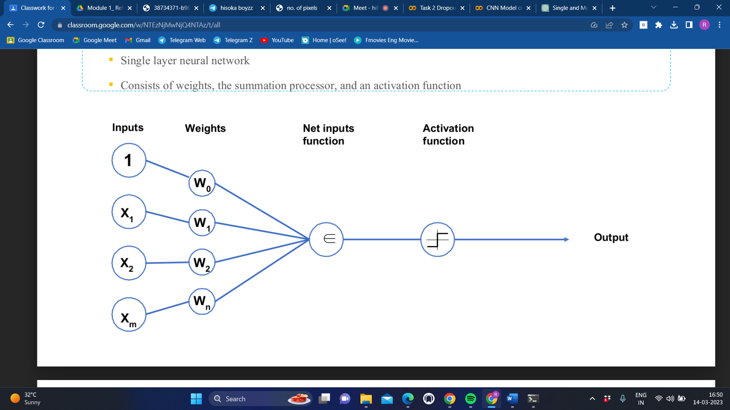

* A multi-layer perceptron (MLP) is a type of neural network that consists of at least one hidden layer between the input and output layers.
* Each neuron in the hidden layer takes a weighted sum of the inputs and applies a nonlinear activation function to produce an output, which is then passed to the next layer until the output layer is reached.
* MLPs are used for a variety of tasks, including classification, regression, and pattern recognition.

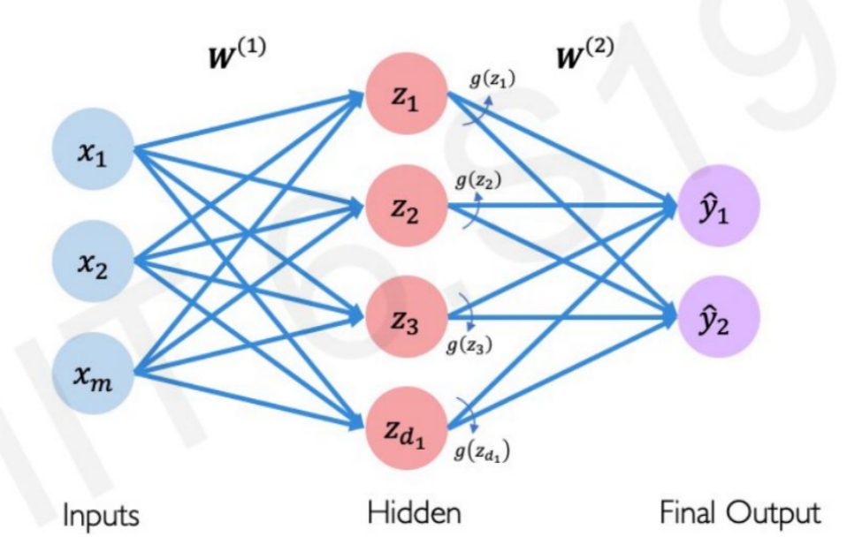

|  |  |  |
| --- | --- | --- |
|  | Shallow Neural Network | Deep Neural Network |
| 1. Number of hidden layers | Only one hidden layer | Multiple hidden layers |
| 1. Performance on complex tasks | Low | High |
| 1. Training time | Short | Long |
| 1. Computational resources required | Low | High |
| 1. Data required for training | Less | More |
| 1. Suitable | Suitable for simple tasks | Suitable for complex tasks |
| 1. Examples of applications | Simple classification tasks | Image recognition, natural language processing, speech recognition |

**Difference between Overfitting and Underfitting** (Bias – training error, variance – testing error)

|  |  |
| --- | --- |
| Overfitting | Underfitting |
| 1. Low Bias, High Variance | 1. High Bias, Low Variance |
| 1. Performs well on training data but poorly on new unseen data | 1. Performs poorly on both training and testing data |
| 1. Model is too complex | 1. Model is simple |
| 1. Training accuracy is high but validation accuracy is low | 1. Training accuracy and validation accuracy are low |
| 1. Happens when training model with noisy data i.e. too many parameters | 1. Happens when model is not trained enough as there is less amount of data |

**Regularization Techniques**

• Regularization is a technique which makes slight modifications to the learning algorithm such that the model generalizes better and prevents overfitting. This in turn improves the model’s performance on the unseen data as well.

**Difference between L1 and L2 Regularisation**

• L1 and L2 are the most common types of regularization. These update the general

cost function by adding another term known as the regularization term.

• In general, the addition of this regularization term causes the values of the weight matrices to reduce, leading simpler models. Therefore, it will also reduce overfitting to quite an extent.

• The difference between L1 and L2 regularization techniques lies in the nature of this regularization term.

**L1 regularization technique:**

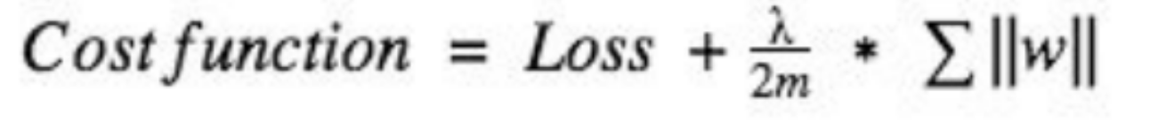

•In L1, the absolute value of the weights are penalised.

• This technique is also called Lasso regularization, useful when the aim is to compress the model.

In this technique, insignificant input features are assigned with zero weight and useful features with non-zero.

**L2 regularization technique :**

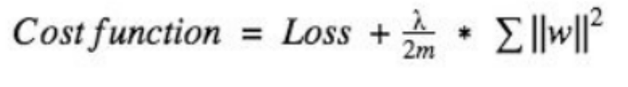

• L2 technique forces the weight to reduce but never makes them zero.

• L2 is also referred to as ridge regularization, this technique performs best when all

the input features influence the output, and all the weights are of almost equal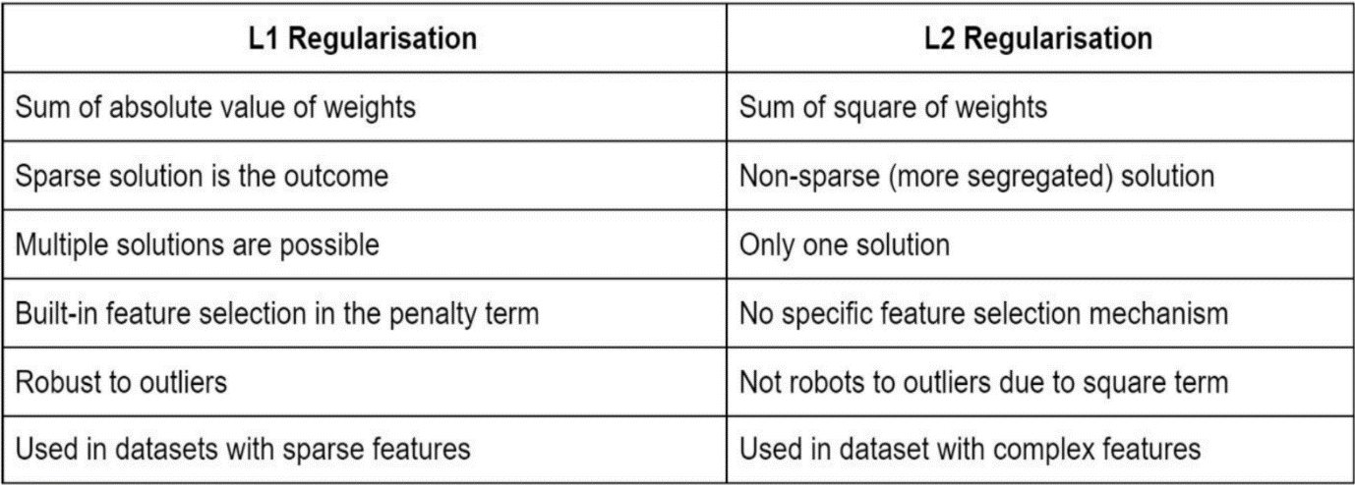 size.

**Dropout:**

• Another most frequently used regularization technique is dropout.

• During the training, randomly selected neurons are ‘dropped’ out or set to zero.

• It means that they are temporarily obstructed from influencing or activating the

downward neuron in a forward pass, and none of the weights updates is applied on

the backward pass.

• So once neurons are randomly dropped out during training, the other neurons step in and make the predictions for the missing neurons.

• This results in independent internal representations being learned by the network,

making the network less sensitive to the specific weight of the neurons.

• Such a network is better generalised and has fewer chances of producing

overfitting.

Typical Probability of Drop out is 0.2 - 0.5

//Note it is mostly used in between hidden layers or before the output layer

**Early Stopping**

• It is a cross-validation strategy where one part of the training set is used as a validation set, and the performance of the model is measured against this set.

• It trains the model for a large number of epochs and keep track of the model's performance on the validation set after each epoch.

• When the validation loss starts to increase or the validation accuracy starts to decrease, the training on the model is immediately stopped.

• At this point, the model parameters from that epoch with the best validation performance can be used as the final model.

• This helps to prevent long continuous training time and improve the model's generalization performance on new, unseen data.

**Data Augmentation**

• This technique helps in reduce overfitting simply by increasing the size of the data.

• Data augmentation is a regularization technique, which is used generally when we have images in folders as data sets.

• It generates additional data artificially from the existing training data by making minor changes such as rotation, flipping, cropping, or blurring a few pixels in the image, and this process generates more and more data.

• Through this regularization technique, the model variance is reduced, which in turn decreases the regularization error.

**Activation Functions**

* Activation functions (transfer function) are an important component in deep learning models.
* The choice of activation function in the hidden layer will control how well the network model learns the training dataset.
* If the output range of the activation function is limited, then it may be called a “squashing function”.
* The output layer will typically use a different activation function from hidden layers that depends upon the type of prediction required by the model.
* They introduce non-linearity to the output of a neuron in a neural network.
* Activation functions are attached to each neuron and are mathematical equations that determine whether a neuron should be activated or not based on whether the neuron’s input is relevant for the model’s prediction or not.

Some commonly used activation functions in deep learning include:

**Sigmoid:** This function is used in the output layer of a neural network for binary classification tasks. It maps the input to a value between 0 and 1, which can be interpreted as the probability of the input belonging to a certain class.

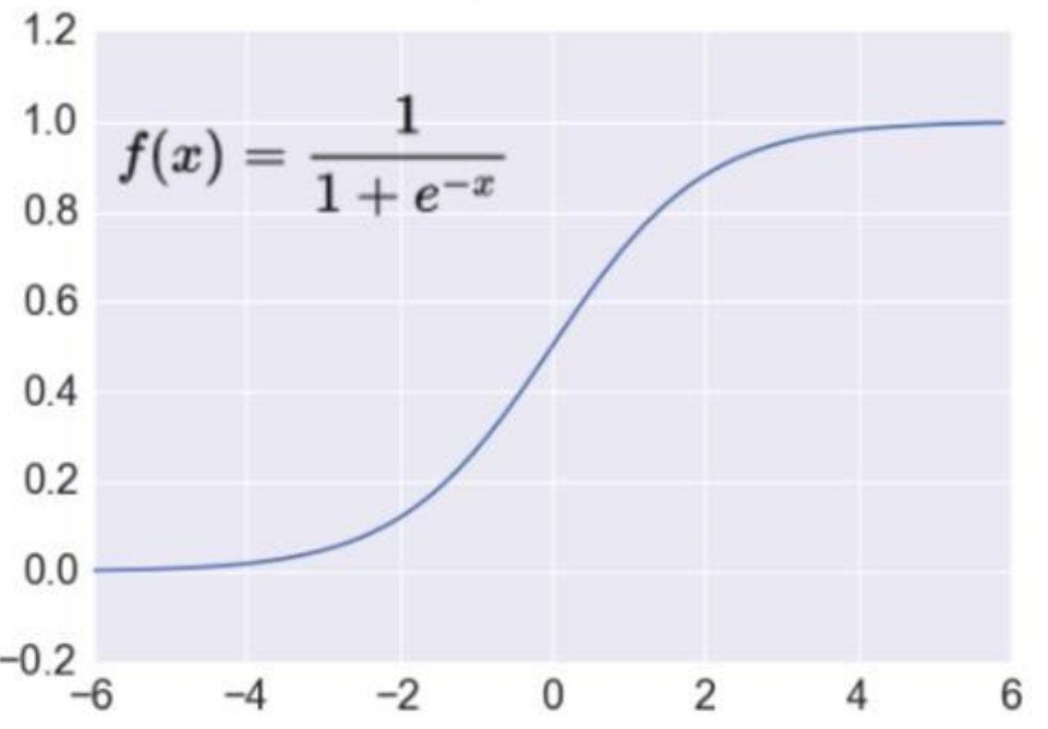

**ReLU (Rectified Linear Unit):** ReLU (Rectified Linear Unit) activation function is often used in the hidden layers of deep neural networks. This function sets all negative values in the input to zero, and leaves positive values unchanged.

ReLU is the most commonly used activation function in deep learning because it is computationally efficient and helps prevent the vanishing gradient problem which can occur when using other activation functions such as sigmoid or tanh. ReLU allows the model to learn and represent more complex and non-linear features.

ReLU avoids the vanishing gradient problem by being a piecewise linear function with a constant gradient of 1 for positive input values, which allows the gradients to flow freely during backpropagation. ReLU also tends to be more computationally efficient than other activation functions, such as sigmoid or tanh, because it involves only a simple thresholding operation without exponentials or logarithms.

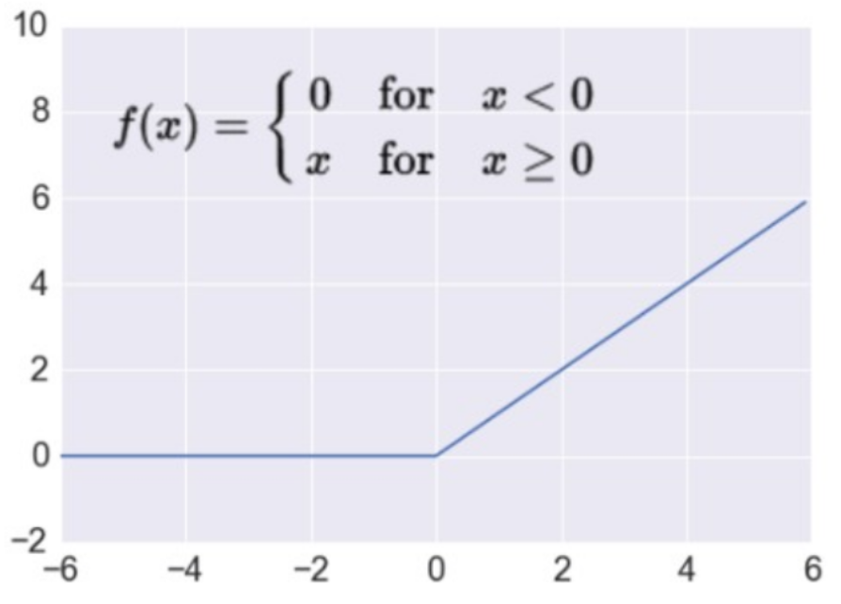

**Tanh (Hyperbolic Tangent):** This function maps the input to a value between -1 and 1, and is commonly used in recurrent neural networks (RNNs).

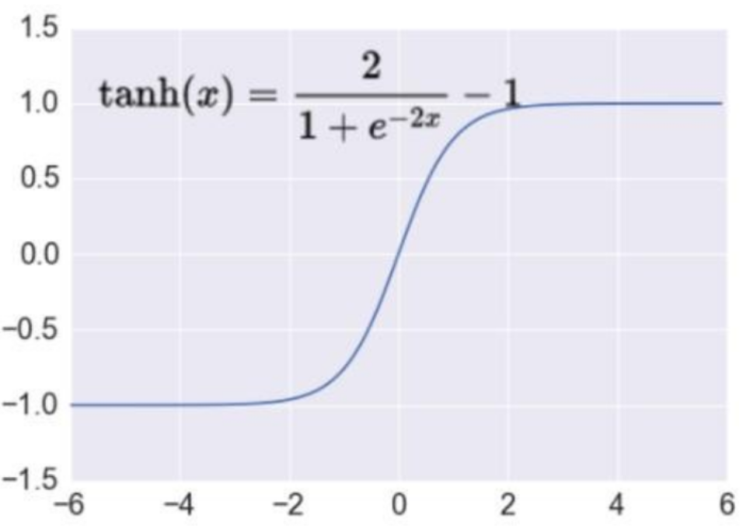

**Softmax**: This function is used in the output layer of a neural network for multi-class classification tasks. It maps the input to a probability distribution over the output classes.

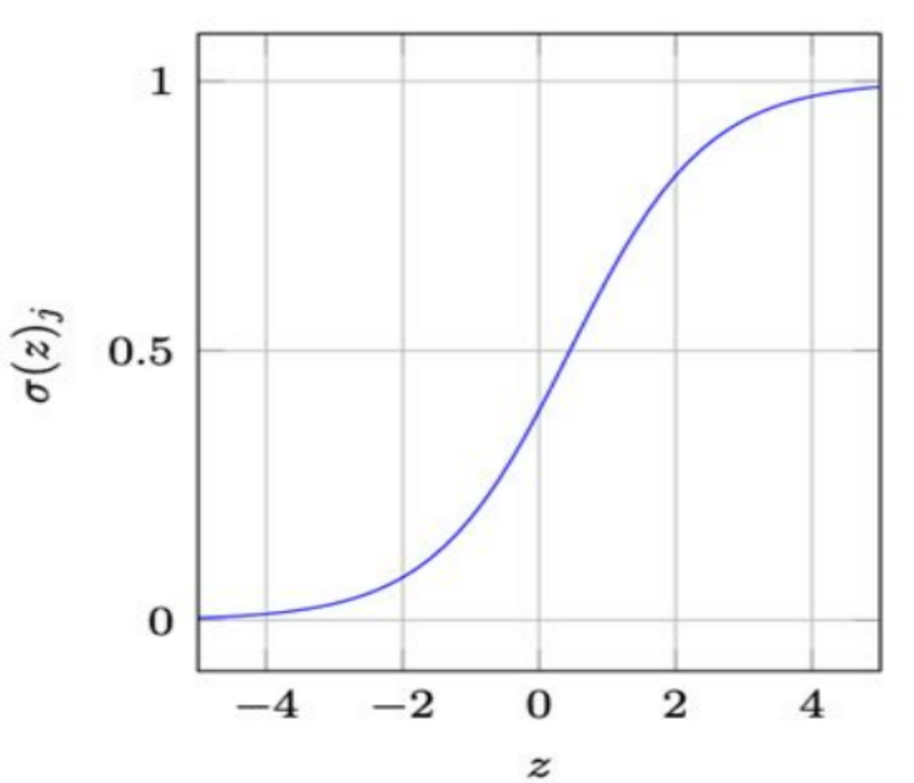

**Leaky ReLU**

Leaky ReLU introduces a small negative slope, such that it outputs a small negative instead of zero when the input is negative. The function is defined as:

|  |  |  |
| --- | --- | --- |
| f(x) = | { | x if x >= 0  ax if x < 0, where a is a small positive constant (e.g., 0.01) |

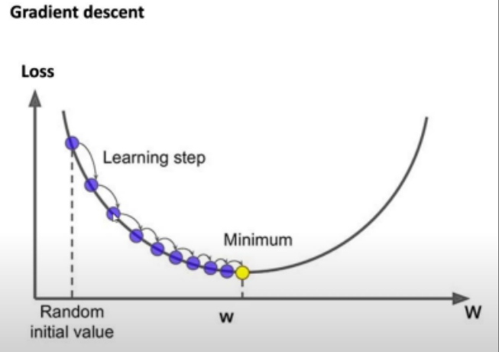

Gradient descent is a popular optimization algorithm used in machine learning to find the minimum value of a function.

The algorithm works by iteratively adjusting the parameters of the function in the direction of the negative gradient until the minimum is reached.

**What is Back Propagation?**

Backpropagation is a commonly used algorithm for training neural networks using gradient descent.

Back propagation is the process of updating and finding the optimal values of weights which helps the model to minimize the error i.e difference between the actual and predicted values.

The backpropagation algorithm works by

first forward propagating an input through the network,

calculates the error or loss in forward propagation and feed this error backwards through the network,

computing the gradient of the loss function with respect to the weights of each neuron to fine-tune the weights.

•The weights are updated with the help of optimizers.

•Optimizers are the methods/ mathematical formulations to change the attributes of neural networks i.e weights to minimize the error.

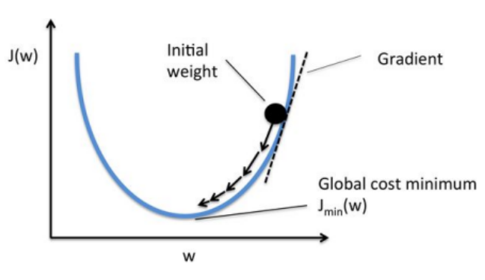

**LEARNING RATE**

•Learning rate is the amount of change or step size taken towards reaching global minima.

• If the learning rate is too high, we might OVERSHOOT the minima and keep bouncing, without reaching the minima

•If the learning rate is too small, the training might turn out to be too long.

•It must be chosen carefully to end up with local minima.

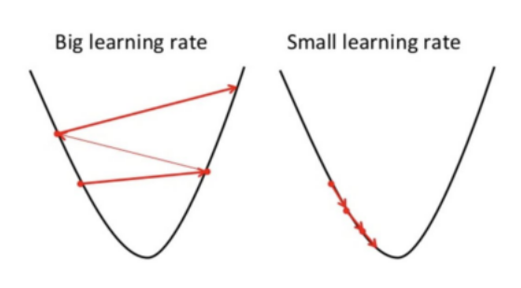

Model compilation is an activity performed after writing the statements in a model and before training starts. It checks for format errors, and defines the loss function, the optimizer or learning rate, and the metrics. A compiled model is needed for training but not necessary for predicting.

**MODULE 2**

**CNN Architecutre**

|  |  |
| --- | --- |
| 1. A combination of convolution with non-linearity and pooling layers can be used for feature extraction | 1. One or more hidden layer at the end of the network. 2. At last, a softmax layer is used for classification purpose. |

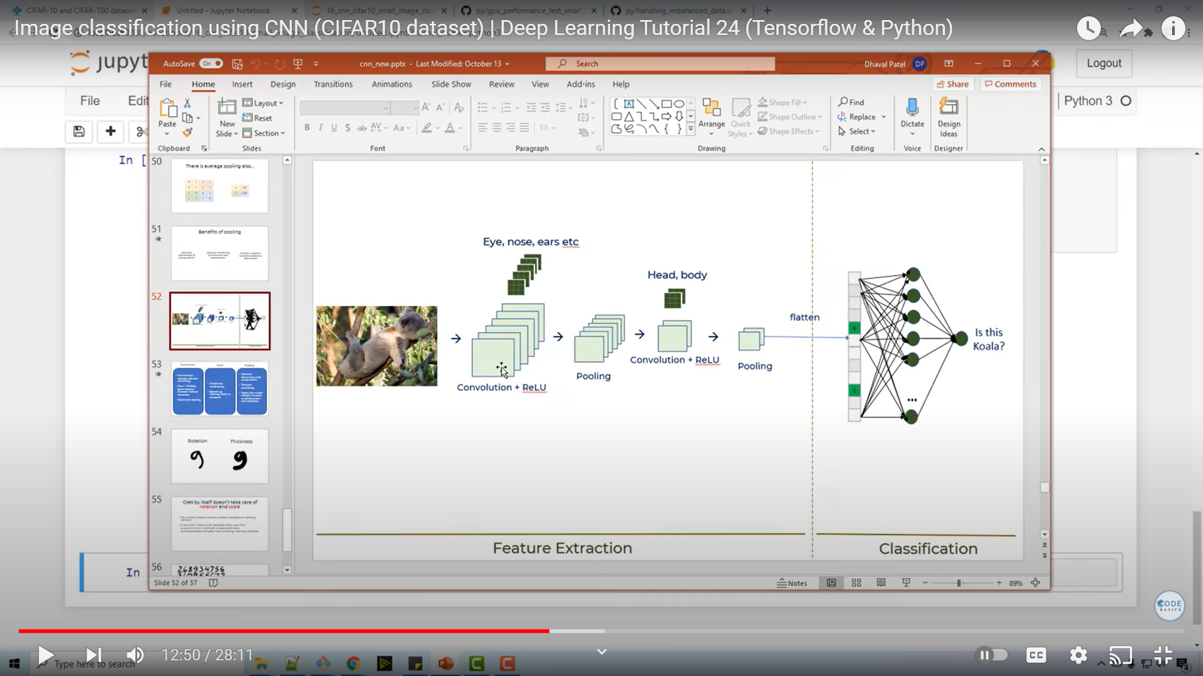

CNN is a multi-layer neural network that is commonly used to extract visual patterns from pixel images and classifies it.

In CNN, ‘convolution’ is referred to as the mathematical function.

It’s a type of linear operation in which two matrices are multiplied to get an output that extracts information from the image.

The basic architecture of a CNN consists of the following layers:

**Convolutional Layer:**

This layer applies a set of learnable filters/kernels to the input image to extract relevant features (like edges, corner) from the image.

Each filter slides over the input image, performing convolution i.e. a dot product between the filter weights and the input pixels in its receptive field, producing a feature map. Multiple filters are applied to create multiple feature maps.

Other than convolution, this layer applies an activation function called Rectified Linear Unit (ReLU) to each element of the feature maps. ReLU sets negative values to zero and keeps positive values unchanged, introducing non-linearity to the model.

**Pooling Layer:**

This layer reduces the spatial size (height and width) of the feature maps as well as the amount of computations by applying a down sampling operation, such as max pooling or average pooling.

The maximum value from the area covered by the kernel on the image is returned by max pooling. The average of all the values in the part of the image covered by the kernel is returned by average pooling. This layer by itself does not have any weights.

**Fully Connected Layer:**

This layer connects every neuron in the previous layer to every neuron in the current layer, producing a flattened feature vector by assembling all the information processed by the various CNN layers so far.

If required this flattened vector is sent to additional FC layers. FC layers are frequently found near the end of CNN.

**Softmax Layer:**

This layer normalizes the output of the fully connected layer into a probability distribution over the possible classes.

Additionally, techniques such as dropout, batch normalization, and regularization can be used to improve the performance and generalization of the model.

|  |  |
| --- | --- |
| Artificial Neural Network (ANN) | Convolutional Neural Network (CNN) |
| 1. Each neuron in the network is connected to every neuron in the adjacent layers | 1. Neurons in convolutional layers are connected only to a small region of the previous layer |
| 1. Used for general-purpose machine learning tasks | 1. Used for image recognition and processing tasks |
| 1. Consists of Input layer, hidden layers, output layer | 1. Consists of Convolutional layer, pooling layer, fully connected layer (in some cases) |
| 1. Suitable for structured data | 1. Suitable for unstructured data |
| 1. Does not preserve spatial information | 1. Preserves spatial information |
| 1. The input can be of any size | 1. The input must have a fixed size |
| 1. Suitable for a wide range of applications | 1. Suitable for specific applications such as image recognition, object detection, and segmentation |

After each convolutional layers with small filter sizes, the size of the feature map can quickly be reduced.

The spatial dimensions of the output volume after convolution can be preserved using zero padding same as previous layer, one zero-pads the input layer.

Zero padding is typically used to ensure the size by adding zeros around the border of the input, therefore the output feature map can be made with same size as the input.

This helps allowing for more complex and accurate feature detection.

For example, if you have a 3x3 image with pixel values of:

1 2 3

4 5 6

7 8 9

and you want to apply a filter that requires a 5x5 input, you can add zero-padding to make it a 5x5 image by adding a border of zeros around it:

0 0 0 0 0

0 1 2 3 0

0 4 5 6 0

0 7 8 9 0

0 0 0 0 0

|  |  |  |
| --- | --- | --- |
| **Padding Type** | **Description** | **Impact** |
| Valid | No padding | Dimensions reduce |
| Same | Zeros around the edges | Dimensions stay the same |

model_same = Sequential([

Dense(16, input_shape=(20,20,3), activation='relu'),

Conv2D(32, kernel_size=(3,3), activation='relu', padding='valid'),

Conv2D(64, kernel_size=(5,5), activation='relu', padding='same'),

Conv2D(128, kernel_size=(7,7), activation='relu', padding='same'),

Flatten(),

Dense(2, activation='softmax')

])

• For example, if the input image has dimensions of 32x32 and we apply a convolutional layer with a 3x3 filter and stride of 1, the resulting feature map would have dimensions of 30x30. However, if we add a zero padding of 1 pixel around the border of the input image, the resulting feature map would have dimensions of 32x32, which is the same as the input image.

Zero Padding = (K-1)/2 where K is the filter size

Output Size = { [ W - K + 2P ] / S } + 1

P - Padding Amount

S - Stride Amount

W - Input Size

K - Filter Size

The distance between two consecutive receptive fields is called the **stride.**

Hyperparameter Tuning: notes for model creation practically

Increasing the epochs

Increasing the batch_size (Increases the accuracy)

Use dropout with 0.2 for each layer (

Check the loss and accuracy for 20 epochs and

if the test loss < train loss till last epochs - reduce the no. of dropouts used or change the dropout rate)

if the test loss > train loss till last epochs - increase the no. of dropouts used or change the dropout rate to 0.5 )

After 20 epochs test loss and train loss becomes equal

Sequence Prediction in Deep Learning

Feedforward networks are widely used for image classification and statistical analysis.

In these networks, connections between the units do not form a reverse circular loop.

As the name suggests, information moves in one direction— from input nodes, through hidden nodes, to the output nodes.

The limitation of feedforward networks is that the output of the complete network does not directly depend on the previous output of the same network. This means that the concept of "recurrence" is missing.

They have separate parameters for each input feature.

Thus the sequence of outputs are independent of each other, which might not be suitable for predictions of words in a sentence.

Hence, Recurrent Neural Networks (RNN) prove to be a better choice for sequence prediction than feedforward networks.

**Advantages of Recurrent Neural Networks**

1. Recurrent Neural Networks can process sequences of large size as well as those with variable length.
2. Parameters share the same weights across several time steps.
3. This recurrence imparts a memory to the network topology.
4. It is based on sharing of parameters across different parts of the model.
5. Each member of the output is a function of previous member’s output.
6. It is produced using the same update rule that is applied to all previous outputs.

Recurrent neural networks are a class of artificial neural networks that create cycles in the network graph in order to exhibit dynamic temporal behaviour.

In simple words, RNNs involve recurrent or circular loops between the neurons, where the output of the network is fed back as an additional input to the network for subsequent processing.

In traditional neural networks, all the inputs and outputs are independent of each other, but in cases like when it is required to predict the next word of a sentence, the previous words are required and hence there is a need to remember the previous words.

The main and most important feature of RNN is Hidden state, which remembers some information about a sequence.

RNN have a “memory” which remembers all information about what has been calculated. It uses the same parameters for each input as it performs the same task on all the inputs or hidden layers to produce the output. This reduces the complexity of parameters, unlike other neural networks.

**Unrolling Network**

Unrolling the network is expanding the network over time to visualize how information flows through the network over a sequence of time steps. 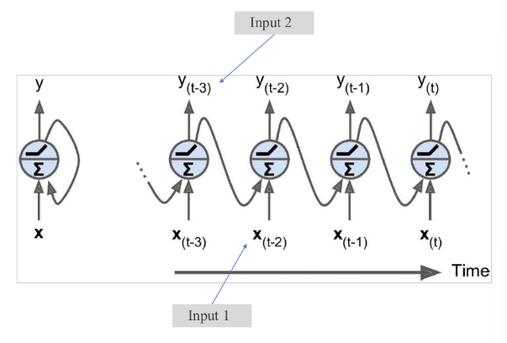

**t** represents a time step also called frame.

The recurrent neuron receives two inputs:

Input 1: Input 1 is the actual input to the network at a particular time step

represented by **xt** at each increment of t.

Input 2: Input 2 is the output of the previous time step fed as an additional input

to the current time step. It is represented by **yt-1.**

Using the recurrent neurons, you can create a layer of recurrent neurons.

In the single recurrent neuron, the input x was a vector and output y was a scalar.

Here, in a layer of recurrent neurons, both x and y are vectors.

Recurrent Neural Network (RNN) is a type of Neural Network where the output from the previous step is fed as input to the current step for subsequent processing.

**Working (ie) training of RNN:**

A recurrent neuron is called a memory cell that tends to preserve memory state across multiple time steps.

The output at time step t is a function of all inputs from previous time steps.

To train an RNN, unroll it through time and then apply backpropagation. This is called backpropagation through time (BPTT).

First, there is a forward pass through the unrolled network (dashed arrows).

A single-time step of the input is provided to the network.

Then calculate its current state using a set of current input x(t) and the previous state h(t-1).

The current h(t) becomes h(t-1) for the next time step.

h(t) = f(h(t-1), x(t))

h(t)=tanh (Whh *h(t-1) +Wxh * x(t))

yt=Why* h(t)

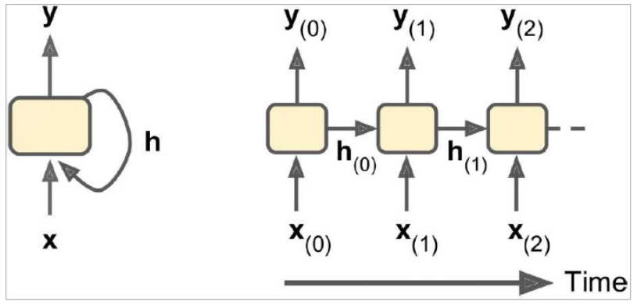

One can go as many time steps according to the problem and join the information from all the previous states.

Once all the time steps are completed the final current state is used to calculate the output.

Then, the output sequence is evaluated using a cost function:

C(Yt-min, Yt-min+1, …., Yt-max)

The sequence starts with the t-min time step, and the outputs at some time steps may be ignored. Then it calculates the gradients using a cost function

Then the gradients of the unrolled network are propagated backward as shown by solid arrows.

Finally, the model parameters are updated using the computed gradients during BPTT.

Note that the gradients flow backward through all the outputs used by the cost function.

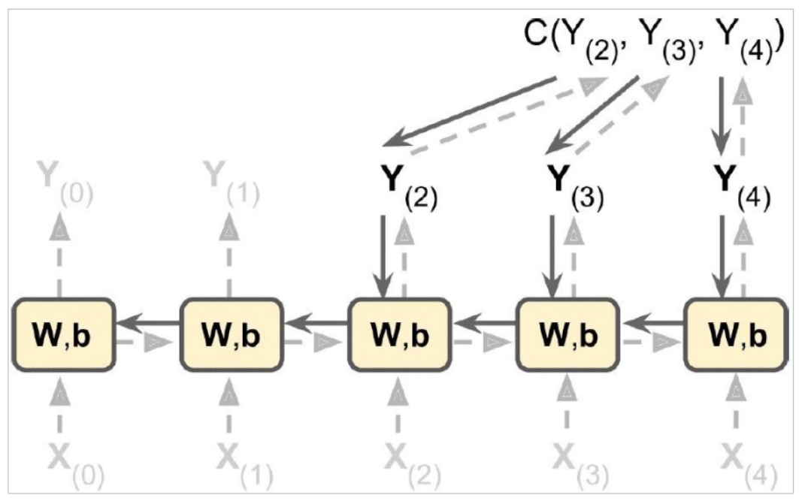

**Configurations of RNN:**

One-to-one: Vanilla mode of processing without RNN where input is passed through a single layer and produces a single output.

For example: Image classification

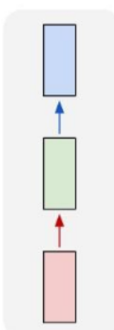

One-to-many: A single input is used to generate a sequence of outputs.

for example, producing a caption for an image.

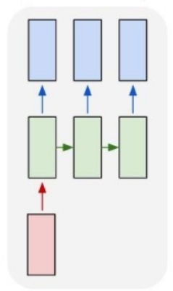

Many-to-one: A sequence of inputs are fed into the network, and a single output is generated. for example, sentiment score (+1 or -1) for a movie review.

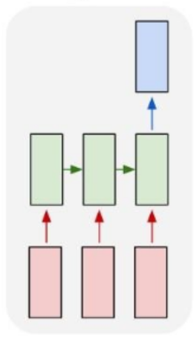

Many-to-many: A sequence of inputs is fed to RNN and generates a sequence of outputs. For example, RNN is used for time series predictions such as stock price., Video classification to label each frame of the video

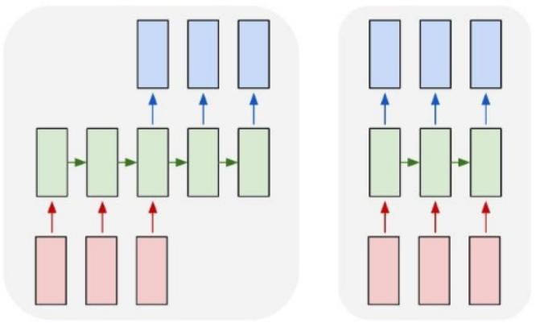

The vanishing gradient problem occurs when the gradients propagated back through more layers of the network become extremely small $≈$ 0.

This can happen when the weights of the network are initialized to small values or when the activation functions used in the network have very small gradients, such as the sigmoid function.

This makes it difficult to train and the network may converge to a suboptimal solution.

The exploding gradient problem occurs when the gradients become extremely large as they are propagated back through the layers of the network.

This can happen when the weights of the network are initialized to large values or when the activation functions used in the network have very large gradients, such as the hyperbolic tangent function (tanh). The network diverges.

The techniques that can be used to prevent this are:

* Good parameter initialization
* Nonsaturating activation functions (e.g., ReLU)
* Batch Normalization
* Gradient Clipping
* Faster optimizers

**LSTM**

LSTM stands for Long Short-Term Memory. It is a type of (RNN) architecture that is designed to overcome the vanishing gradient problem in traditional RNNs, which occurs when the gradients used for backpropagation become too small $≈$ 0.

LSTM by means of logic gates controls what information gets passed forward and what gets dropped.

LSTMs are very successful in modelling long-term time series, long texts, audio recordings, etc.

LSTM cells perform much better, converge faster, and learn long-term dependencies.

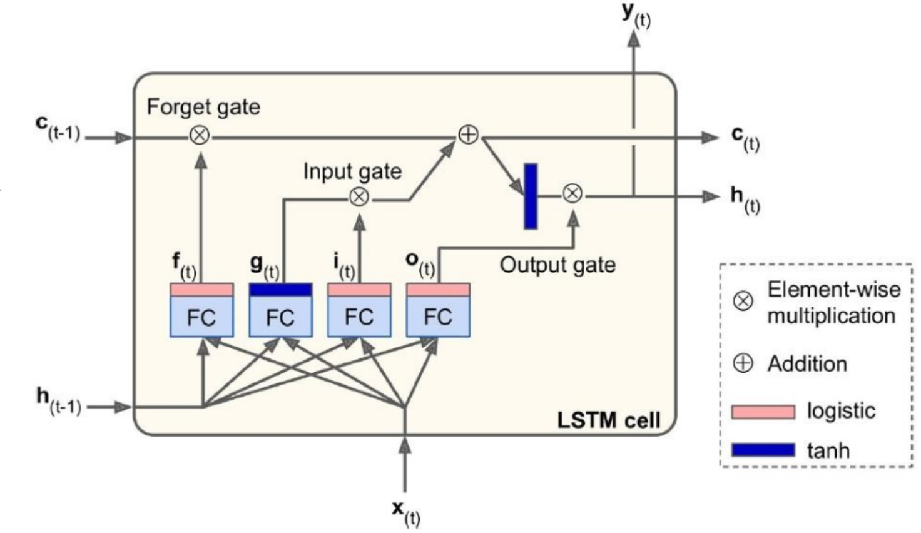

**State of LSTM cells:**

An LSTM cell manages two state vectors instead of just one.

An LSTM cell has two states:

c(t) - long-term state

h(t) - short-term state

1. The current input x(t) and previous short-term state h(t-1) are fed to four fully connected layers.
2. The main layer is the one uses tanh function producing output g(t). This layer is partially stored in the long-term state (controlled by the input gate).
3. The other three layers are gate controllers. They use logistic activation function, so their output can be 0 or 1.
4. If the output is 0, the corresponding gate is closed or else it is left open.
5. The output f(t) controls the forget gate, which decides what part of long-term state is deleted.
6. The output i(t) controls the input gate, which decides what part of g(t) gets added to the long- term state.
7. The output o(t) controls the output gate, which decides what part of long-term state can be stored in h(t) and y(t).
8. The long-term state passes through forget gate to forget some memories and input gate to allow some memories.
9. The long-term state is then passed through gate for addition without transformation.
10. The long-term state is also taken through tanh operation. The result is filtered by the output gate to produce short-term state h(t).
11. This is equal to the cell’s output for the time step y(t).

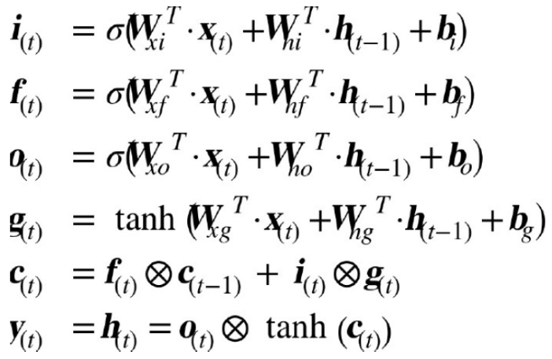

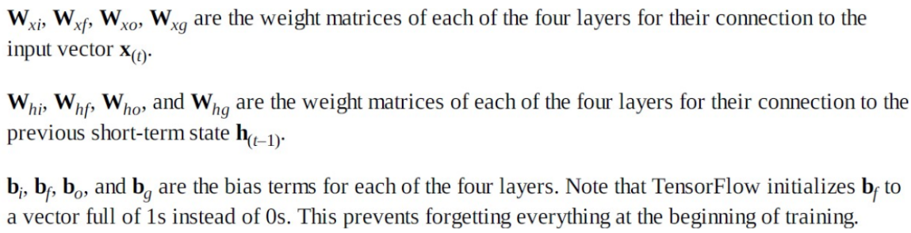

**Transfer Learning**

Transfer learning is the reuse of a pre trained model on new problem.

Transfer learning is a technique that allows a model to use knowledge learned from a previous related task to improve its performance on a new task.

**How it works?**

In transfer learning, a pre-trained model is used as a starting point for a new task, and the knowledge learned from the previous task is transferred to the new task.

The pre-trained model is fine-tuned on the new task, that is the model's weights are adjusted to make it more suitable for the new task.

Fine-tuning involves updating some or all of the model's parameters using the new data.

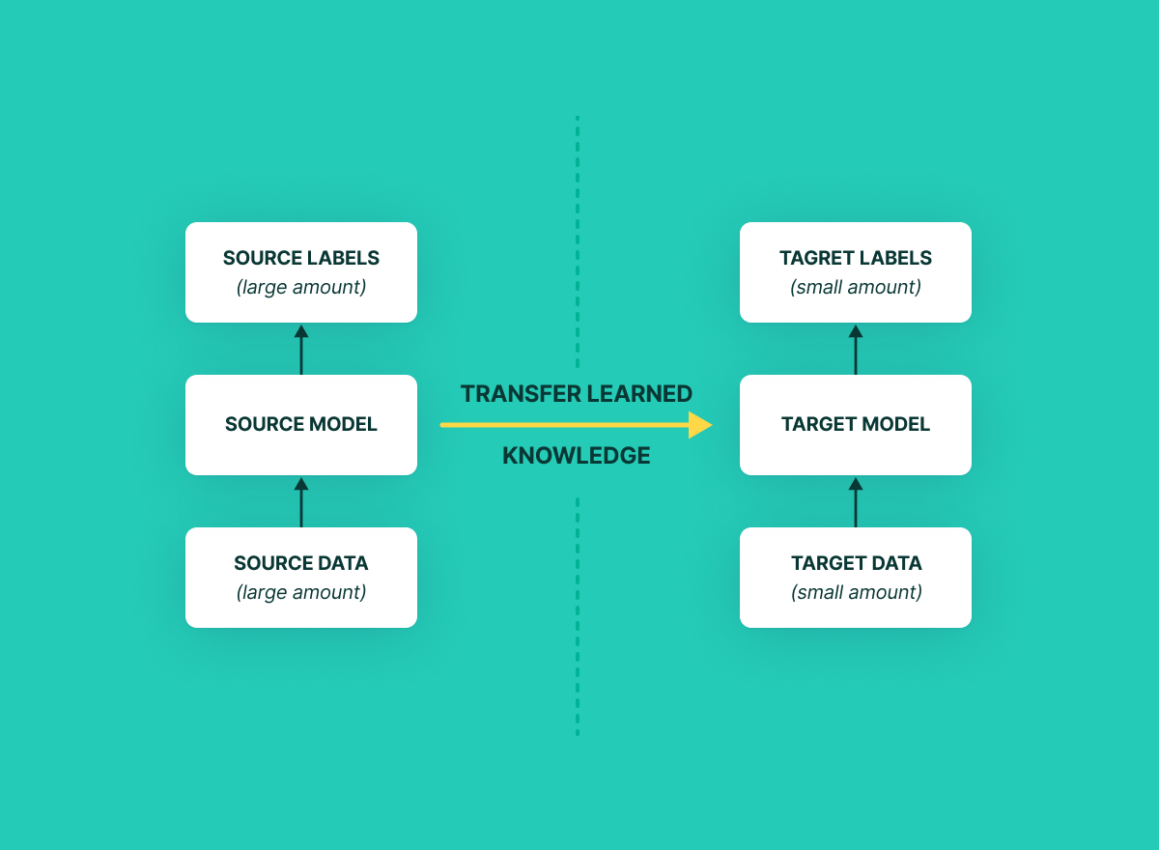

**When to use?**

Transfer learning is useful when there is no enough data available for a new task, when you have related data or when training a model from scratch is too expensive.

By using a pre-trained model, a new model can be trained with fewer resources in less time.

**Approaches:**

1. TRAINING A MODEL TO REUSE IT

To solve a task A with no enough data to train. You can find a related task B with abundant data of similar input. Train the deep neural network on task B and reuse the model as a starting point for solving task A.

2. USING A PRE-TRAINED MODEL

A pre-trained model refers to a model or a saved network created by someone else that is trained on a large dataset to solve a similar problem.

This type of transfer learning is most commonly used.

3. FEATURE EXTRACTION

The pre-trained model is used as a fixed feature extractor. The output of one or more layers of the pre-trained model is used as input to a new model, which is trained on the new task. This is useful when the new task has a similar input space.

IMAGENET DATASET:

ImageNet is a dataset of over 15 million labeled high-resolution images belonging to roughly 22,000 categories. The images were collected from the web and labeled by human labelers using Amazon’s Mechanical Turk crowd-sourcing tool. Starting in 2010, as part of the Pascal Visual Object Challenge, an annual competition called the ImageNet Large-Scale Visual Recognition Challenge (ILSVRC) has been held. ILSVRC uses a subset of ImageNet with roughly 1000 images in each of 1000 categories. At all, there are roughly 1.2 million training images, 50,000 validation images, and 150,000 testing images. ImageNet consists of variable-resolution images. Therefore, the images have been down-sampled to a fixed resolution of 256×256. Given a rectangular image, the image is rescaled and cropped out the central 256×256 patch from the resulting image.

AlexNet – Winner of 2012 ImageNet Competition

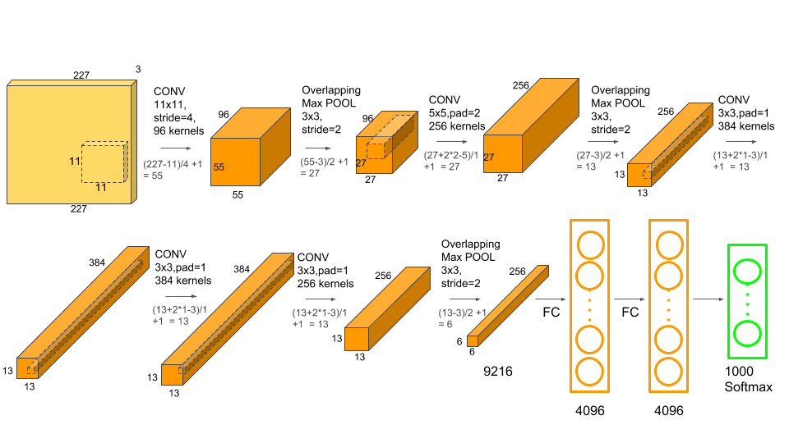

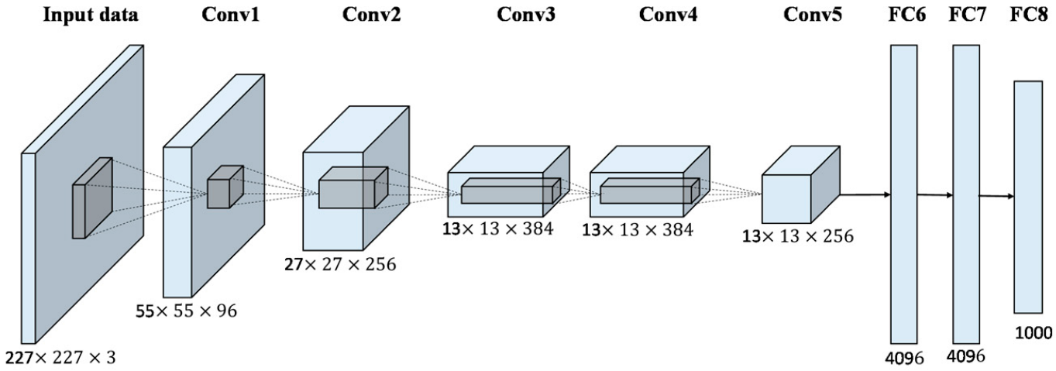

**Configuration:**

5 convolutional layers,

3 overlapping max pooling 3x3 with stride=2

3 fully connected layers (Last one – softmax)

Relu is followed after all layers

Filter sizes: 11x11, 5x5,3x3

Relu is used to accelerates the speed by 6 times at the same accuracy.

Use dropout of 0.5 to overcome overfitting for 1 and 2 FC layer.

AlexNet uses the ReLU activation function, max pooling, dropout, and local response normalization techniques.

It was trained on two Nvidia Geforce GTX 580 GPUs for 50 epochs. and has approximately 60 million parameters

Overall, the combination of these elements enabled AlexNet to achieve state-of-the-art performance on the ImageNet dataset.

Overlap pooling to reduce the size of the network. It reduces the top-1 and top-5 error rates by 0.4% and 0.3%, respectively.

The network achieves top-1 and top-5 test set error rates of 37.5% and 17.0%.

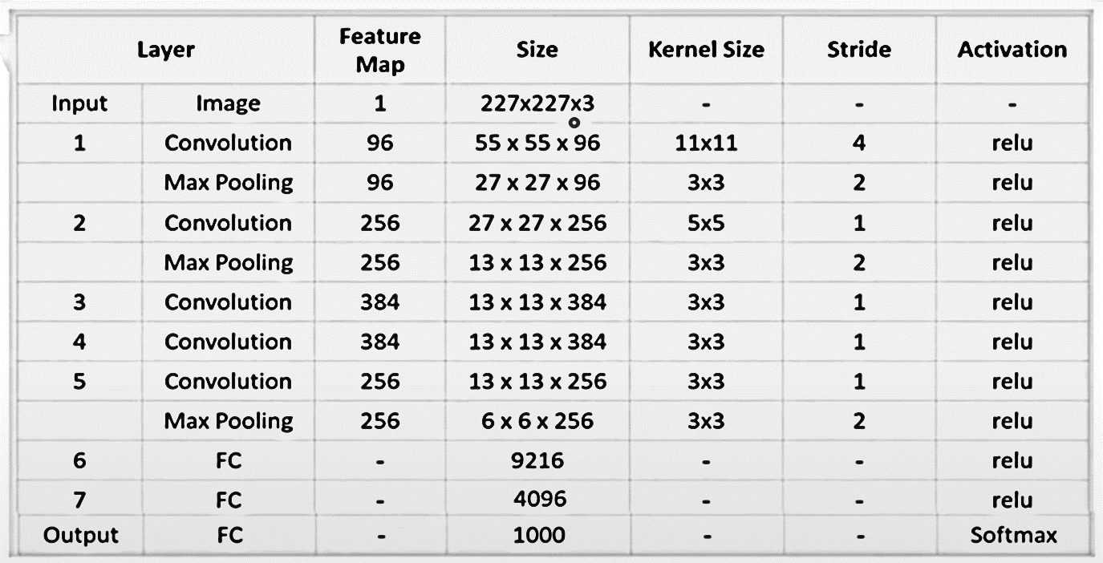

Code:

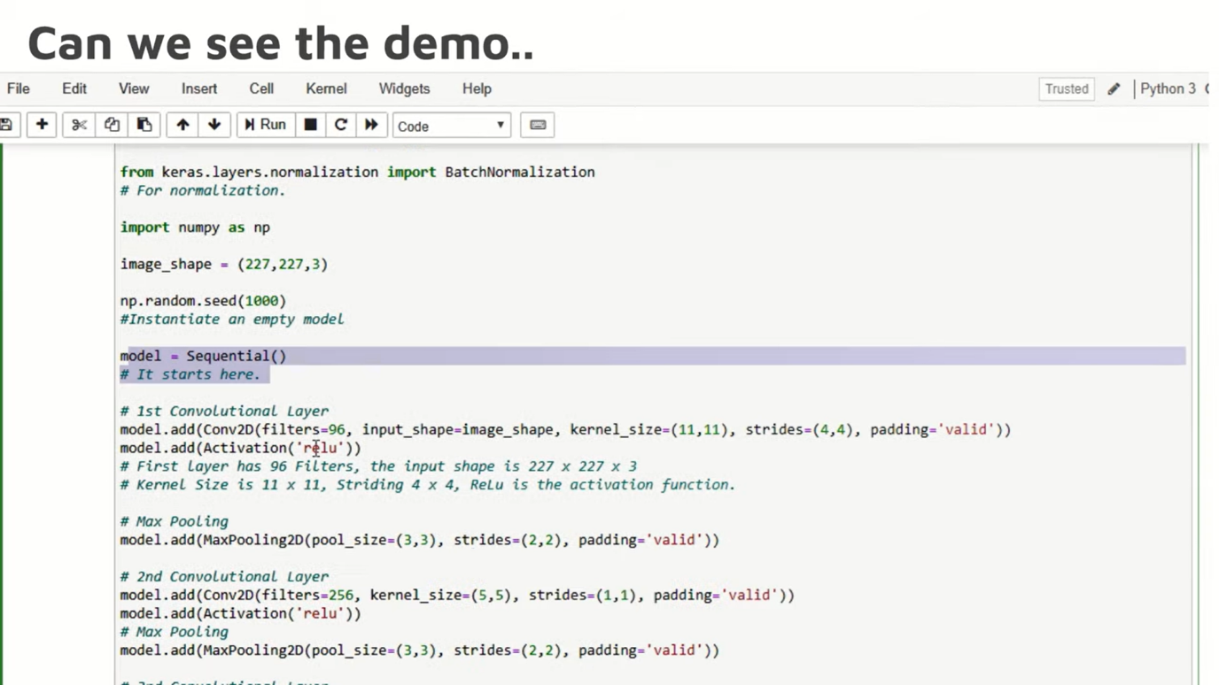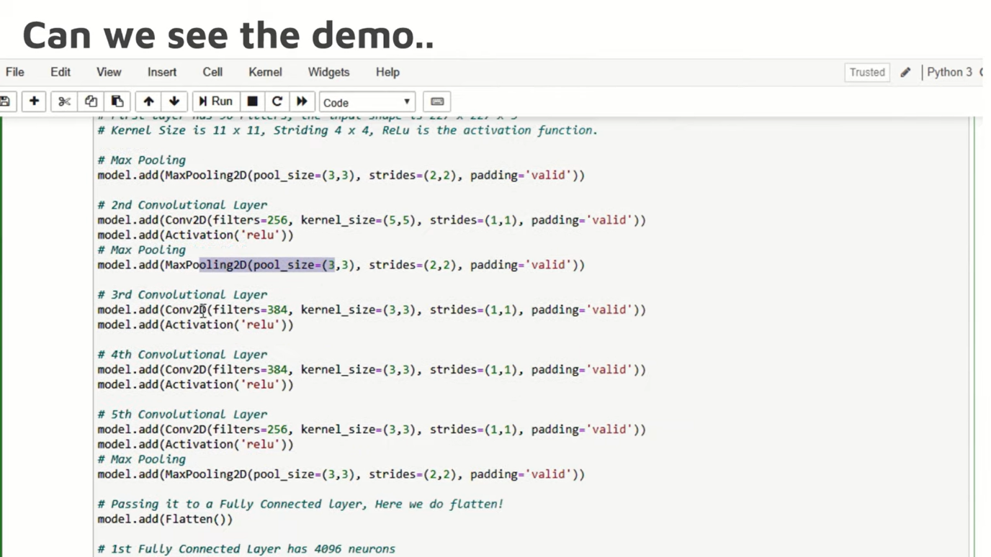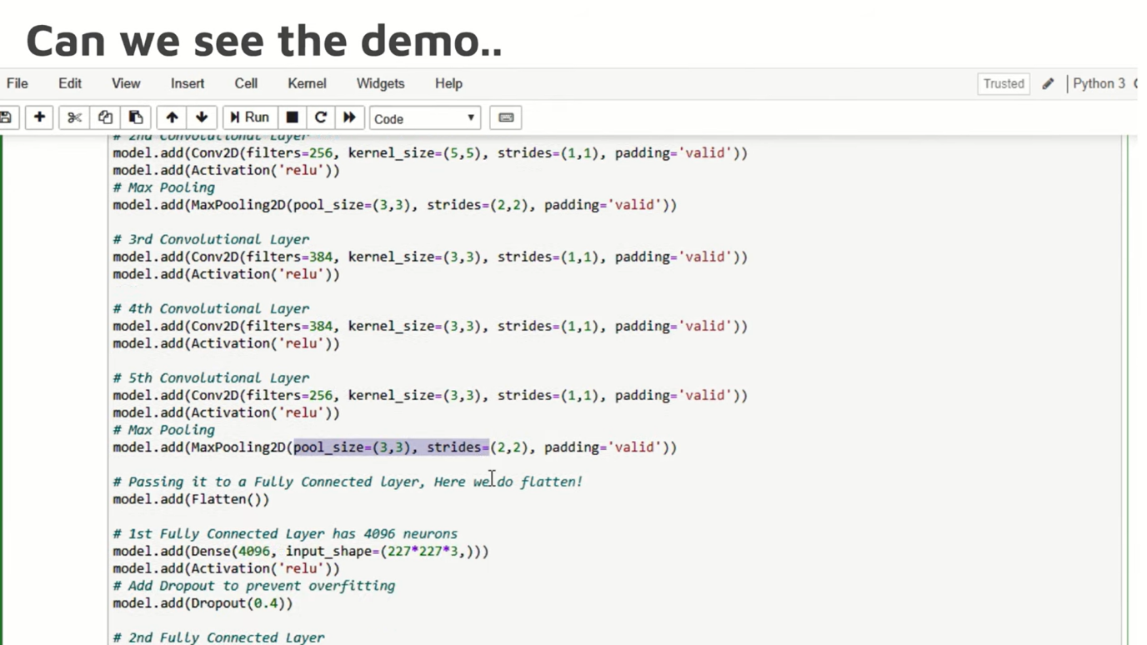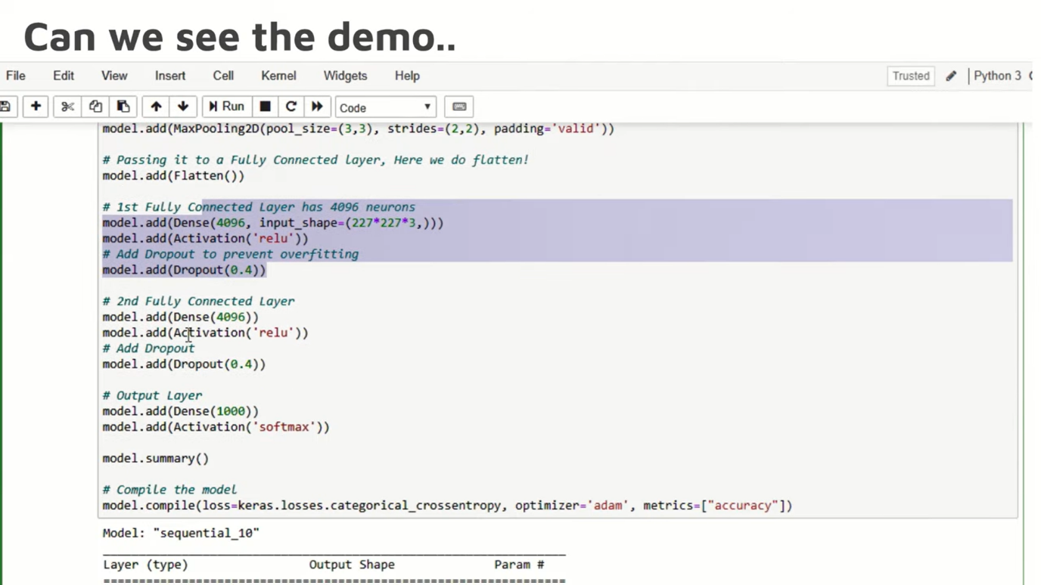

VGGNet-16:

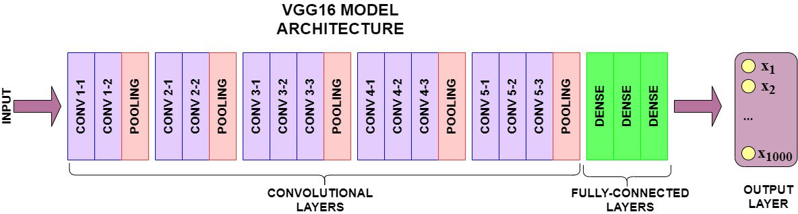

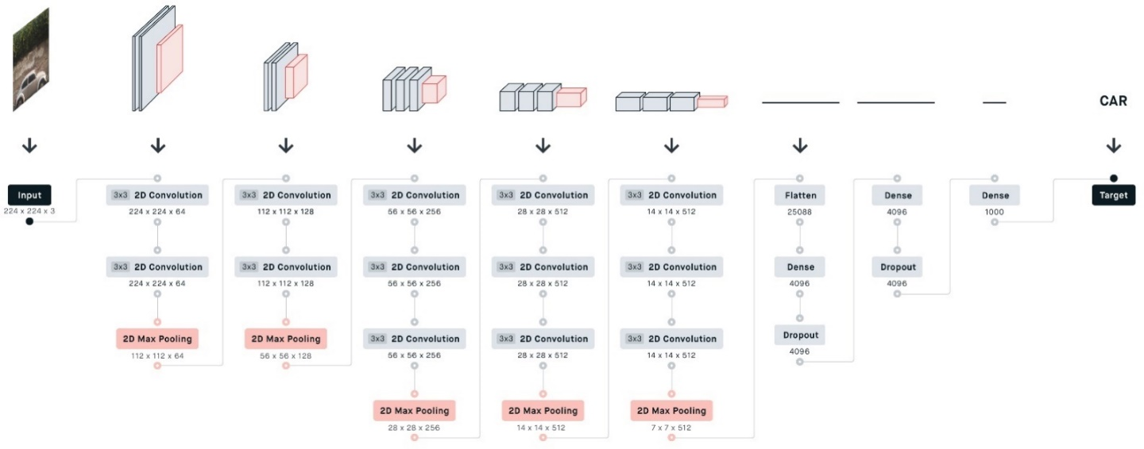

|  |  |  |  |  |  |  |  |
| --- | --- | --- | --- | --- | --- | --- | --- |
| Layer | Feature Map | Filters | Size | Kernel Size | Stride |  | Activation |
| Image -Input | 1 |  | 224x224x3 | - | - | - | - |
| 2xConv | 64 | 64 | 224x224x64 | 3x3 | 1 |  | Relu |
| MaxPooling | 64 |  | 112x112x64 | 3x3 | 2 |  | Relu |
| 2xConv | 128 | 128 | 112x112x128 | 3x3 | 1 |  | Relu |
| MaxPooling | 128 |  | 56x56x128 | 3x3 | 2 |  | Relu |
| 3xConv | 256 | 256 | 56x56x256 | 3x3 | 1 |  | Relu |
| MaxPooling | 256 |  | 28x28x256 | 3x3 | 2 |  | Relu |
| 3xConv | 512 | 512 | 28x28x512 | 3x3 | 1 |  | Relu |
| MaxPooling | 512 |  | 14x14x512 | 3x3 | 2 |  | Relu |
| 3xConv | 512 | 512 | 14x14x512 | 3x3 | 1 |  | Relu |
| MaxPooling | 512 |  | 7x7x512 | 3x3 | 2 |  | Relu |
| FC |  |  | 25088 |  |  |  | Relu |
| FC |  |  | 4096 |  |  |  | Relu |
| FC |  |  | 4096 |  |  |  | Relu |
| Output |  |  | 1000 |  |  |  | Softmax |

**What is VGG16**

VGG16 is a type of CNN (Convolutional Neural Network) that is considered to be one of the best computer vision models till date.

The creators of this model evaluated the networks with very small (3 × 3) convolution filters, which showed a significant improvement.

They pushed the depth to 16–19 weight layers making it approx — 138 Million trainable parameters.

VGG16 is able to classify 1000 images of 1000 different categories with 92.7% accuracy

**Configuration:**

1. Convolutional Layers: 13
2. Fully Connected Layers: 3
3. Stride: 1
4. ReLu: Follow all hidden layers
5. Max-Pooling: 5 with 2x2 window
6. Padding: (same) s/t spatial resolution is preserved
7. Convolutional filters: Starts from 64, which doubles after each max-pooling layer until 512
8. Filter sizes: 3x3

**Result:**

VGG-16 was one of the best performing architectures in the ILSVRC challenge 2014.

It was the runner up in the classification task with a top-5 error of 7.32%. It was also the winner of localization task with 25.32% localization error.

**Limitations Of VGG 16:**

It is very slow to train (the original VGG model was trained on Nvidia Titan GPU for 2-3 weeks).

The size of VGG-16 trained imageNet weights is 528 MB. So, it takes quite a lot of disk space and bandwidth which makes it inefficient.

138 million parameters lead to exploding gradients problem.

tf.keras.applications.VGG16(

include_top=True, //If it is false u can pass ur input with any input shape

weights="imagenet",

input_tensor=None,

input_shape=None,

pooling=None,

classes=1000,

classifier_activation="softmax",

)

* ResNet, short for Residual Networks is a classic neural network used as a backbone for many computer vision tasks.
* This model was the winner of ImageNet challenge in 2015. The fundamental breakthrough with ResNet was it allowed us to train extremely deep neural networks with 150+layers successfully.
* The presence of a residual learning framework eases the training of networks while deeper neural networks are more difficult to train 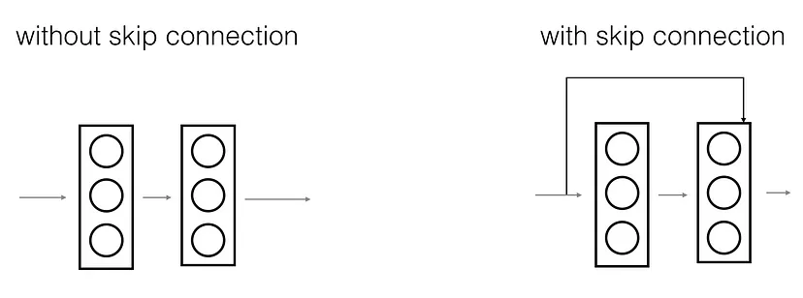

**Skip Connection — The Strength of ResNet**

ResNet first introduced the concept of skip connection. The figure on the left is stacking convolution layers together one after the other. On the right we still stack convolution layers as before with skip connections, these connections allow the network to bypass one or more layers and connect the input directly to a deeper layer. The original input can be added to the output of the convolution block. This is called skip connection

The skip connection is applied before the RELU activation

**Why do we skip connections?**

They mitigate the problem of vanishing gradient by allowing gradient to flow through the alternate shortcut path

They allow the model to learn an identity function which ensures that the higher layer will perform at least as good as the lower layer, and not worse

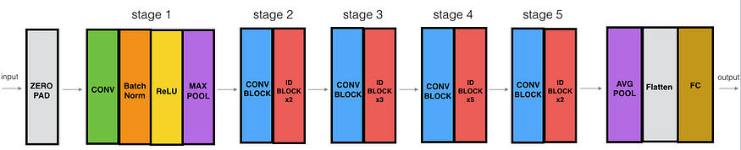

* The ResNet-50 model consists of 5 stages each with a convolution and Identity block.
* Each convolution block has 3 convolution layers and each identity block also has 3 convolution layers.
* The ResNet-50 has over 23 million trainable parameters.

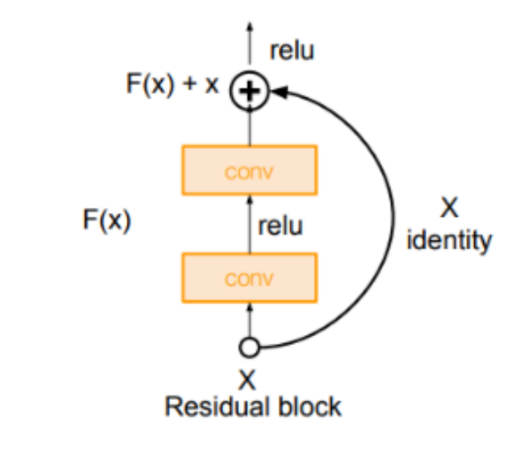

**ResNet Features**

1. Reduces resolution only in the first layer therefore, reducing memory consumption
2. Maintains resolution and channels in each stage
3. Averages values from each channel fed to the linear classifier
4. Divides each stage into residual blocks

**ResNet: Experimental Results**

Despite having extremely deep architecture (based on layers) as compared to VGG-16 and VGG-19, ResNet model size is much smaller due to global average pooling rather than fully-connected layers.

Inception v3

Inception v3 is an image recognition model produced accuracy greater than 78.1% on the ImageNet dataset.

Inception is a deep neural network architecture that was developed to improve the performance of convolutional neural networks (CNNs) in image recognition tasks. It was introduced in 2014 by researchers at Google.

Inception uses a unique module called the Inception module, which performs multiple parallel convolutional operations with different filter sizes and pooling operations in parallel.

The outputs of these operations are then concatenated together and fed into the next layer of the network.

This approach allows the network to learn both local and global features from the input image, making it more effective at recognizing objects in images.

The Inception module also uses 1x1 convolutions, which help to reduce the number of parameters in the network and prevent overfitting. This is because 1x1 convolutions perform dimensionality reduction, which reduces the size of the feature maps while preserving important information.

**Features:**

Multiple Convolutional Layers: Inception uses multiple convolutional layers of different sizes in parallel, allowing it to capture features at different scales.

Inception Modules: Inception architecture uses Inception modules that combine multiple convolutional layers of different sizes to extract features from the input image.

Dimensionality Reduction: Inception also uses dimensionality reduction techniques like 1x1 convolutions to reduce the number of input channels to the next layer, helping to improve the efficiency of the network.

Global Average Pooling: Inception uses global average pooling as the last layer instead of fully connected layers, which helps to reduce overfitting and makes the network more robust.

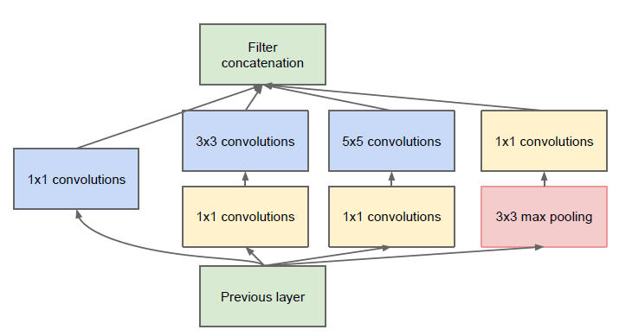

Inception v3 Architecture

The architecture of an Inception v3 network is progressively built, step-by-step, as explained below

1. Factorized Convolutions: this helps to reduce the computational efficiency along with network efficiency as it reduces the number of parameters involved in a network.

2. Smaller convolutions: replacing bigger convolutions with smaller convolutions definitely leads to faster training. Say a 5 × 5 filter has 25 parameters; two 3 × 3 filters replacing a 5 × 5 convolution has only 18 (3*3 + 3*3) parameters instead

In the middle we see a 3x3 convolution, and below a fully-connected layer. Since both 3x3 convolutions can share weights among themselves, the number of computations can be reduced.

3. Asymmetric convolutions: A 3 × 3 convolution could be replaced by a 1 × 3 convolution followed by a 3 × 1 convolution. If a 3 × 3 convolution is replaced by a 2 × 2 convolution, the number of parameters would be slightly higher than the asymmetric convolution proposed.

4. Auxiliary classifier: an auxiliary classifier is a small CNN inserted between layers during training, and the loss incurred is added to the main network loss. In GoogLeNet auxiliary classifiers were used for a deeper network, whereas in Inception v3 an auxiliary classifier acts as a regularizer.

1. Grid size reduction: Grid size reduction is usually done by pooling operations. However, to combat the bottlenecks of computational cost, a more efficient technique is proposed:

Inception V3 is a popular convolutional neural network (CNN) architecture used for image classification tasks. It uses a module called the "Inception module," which allows for more efficient use of computation and parameter tuning.

Inception v3

Inception v3 is an image recognition model produced accuracy greater than 78.1% on the ImageNet dataset.

Inception is a deep neural network architecture that was developed to improve the performance of convolutional neural networks (CNNs) in image recognition tasks. It was introduced in 2014 by researchers at Google.



The key features of the Inception V3 model include:

Inception modules: These modules contain a combination of 1x1, 3x3, and 5x5 convolutions to extract features at multiple scales.

Factorization: To further reduce the number of parameters, the 5x5 convolutions are factorized into two consecutive 3x3 convolutions.

Asymmetric convolutions: A 3 × 3 convolution could be replaced by a 1 × 3 convolution followed by a 3 × 1 convolution. If a 3 × 3 convolution is replaced by a 2 × 2 convolution, the number of parameters would be slightly higher than the asymmetric convolution proposed.

Auxiliary classifier: The model includes two auxiliary classifiers at intermediate layers to improve gradient flow and regularize the network.

Dimensionality Reduction: Inception also uses dimensionality reduction techniques like 1x1 convolutions to reduce the number of input channels to the next layer, helping to improve the efficiency of the network.

Batch normalization: The model uses batch normalization to speed up training and reduce overfitting.

Pre-training: The model is often pre-trained on a large dataset (e.g. ImageNet) before fine-tuning on a specific task, which helps to improve its accuracy.

The outputs of these operations are then concatenated together and fed into the next layer of the network.

Overall, Inception V3 is known for its high accuracy on image classification tasks while maintaining relatively few parameters.

Autoencoder is an unsupervised artificial neural network that learns how to efficiently compress and encode data then learns how to reconstruct the data back from the reduced encoded representation to a representation that is as close to the original input as possible.

Autoencoder, by design, reduces data dimensions by learning how to ignore the noise in the data.

Autoencoder objective is to minimize reconstruction error between the input and output. This helps autoencoders to learn important features present in the data. When a representation allows a good reconstruction of its input then it has retained much of the information present in the input.

What are different types of Autoencoders?

Undercomplete Autoencoders

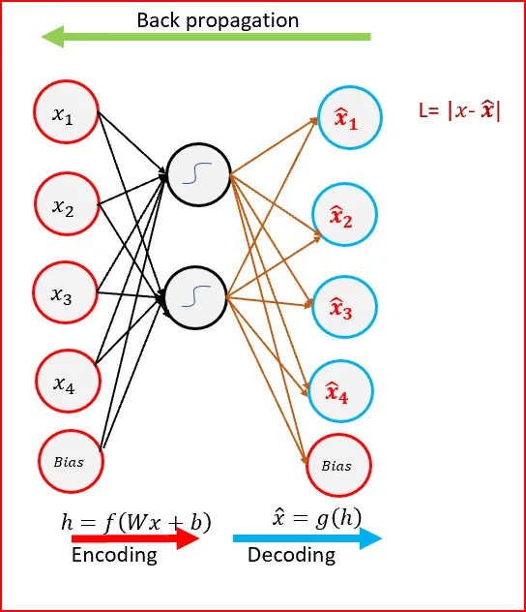

Undercomplete Autoencoder- Hidden layer has smaller dimension than input layer

Goal of the Autoencoder is to capture the most important features present in the data.

Undercomplete autoencoders have a smaller dimension for hidden layer compared to the input layer. This helps to obtain important features from the data.

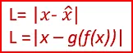Objective is to minimize the loss function by penalizing the g(f(x)) for being different from the input x.

When decoder is linear and we use a mean squared error loss function then undercomplete autoencoder generates a reduced feature space similar to PCA

We get a powerful nonlinear generalization of PCA when encoder function f and decoder function g are non linear.

Undercomplete autoencoders do not need any regularization as they maximize the probability of data rather than copying the input to the output.

Sparse Autoencoders

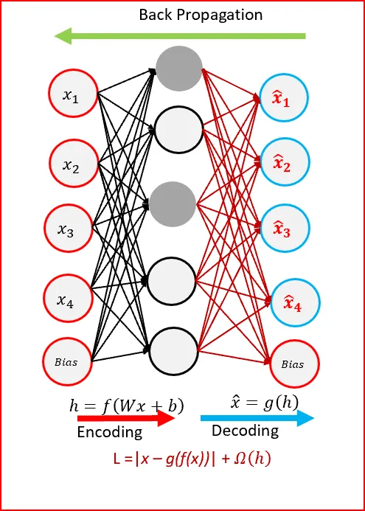

Sparse Autoencoders use only reduced number of hidden nodes at a time

Sparse autoencoders have hidden nodes greater than input nodes. They can still discover important features from the data.

Sparsity constraint is introduced on the hidden layer. This is to prevent output layer copy input data.

Sparse autoencoders have a sparsity penalty, Ω(h), a value close to zero but not zero. Sparsity penalty is applied on the hidden layer in addition to the reconstruction error. This prevents overfitting.

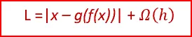

Sparse autoencoders take the highest activation values in the hidden layer and zero out the rest of the hidden nodes. This prevents autoencoders to use all of the hidden nodes at a time and forcing only a reduced number of hidden nodes to be used.

As we activate and inactivate hidden nodes for each row in the dataset. Each hidden node extracts a feature from the data

**Denoising Autoencoders(DAE)**

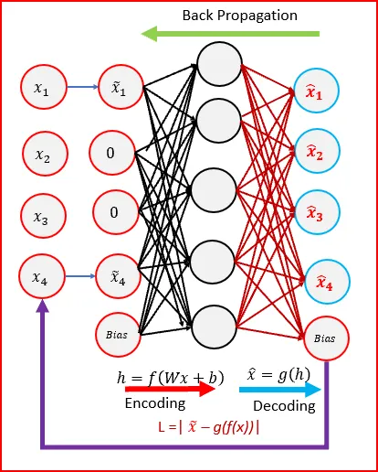

Denoising Autoencoders — input is corrupted

Denoising refers to intentionally adding noise to the raw input before providing it to the network. Denoising can be achieved using stochastic mapping.

Denoising autoencoders create a corrupted copy of the input by introducing some noise. This helps to avoid the autoencoders to copy the input to the output without learning features about the data.

Corruption of the input can be done randomly by making some of the input as zero. Remaining nodes copy the input to the noised input.

Denoising autoencoders must remove the corruption to generate an output that is similar to the input. Output is compared with input and not with noised input. To minimize the loss function we continue until convergence

Denoising autoencoders minimizes the loss function between the output node and the corrupted input.

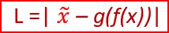

Denoising helps the autoencoders to learn the latent representation present in the data. Denoising autoencoders ensures a good representation is one that can be derived robustly from a corrupted input and that will be useful for recovering the corresponding clean input.

Denoising is a stochastic autoencoder as we use a stochastic corruption process to set some of the inputs to zero

Contractive Autoencoders(CAE)

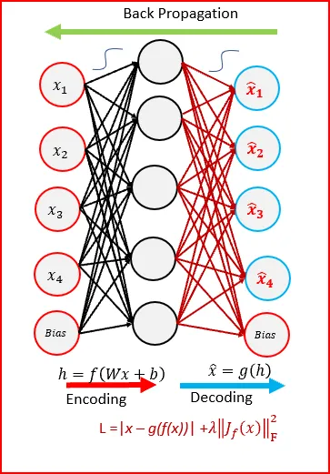

Contractive autoencoder(CAE) objective is to have a robust learned representation which is less sensitive to small variation in the data.

Robustness of the representation for the data is done by applying a penalty term to the loss function. The penalty term is Frobenius norm of the Jacobian matrix. Frobenius norm of the Jacobian matrix for the hidden layer is calculated with respect to input. Frobenius norm of the Jacobian matrix is the sum of square of all elements.

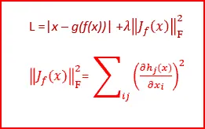

Loss function with penalty term — Frobenius norm of the Jacobian matrix

Contractive autoencoder is another regularization technique like sparse autoencoders and denoising autoencoders.

CAE surpasses results obtained by regularizing autoencoder using weight decay or by denoising. CAE is a better choice than denoising autoencoder to learn useful feature extraction.

Penalty term generates mapping which are strongly contracting the data and hence the name contractive autoencoder.

Stacked Denoising Autoencoders

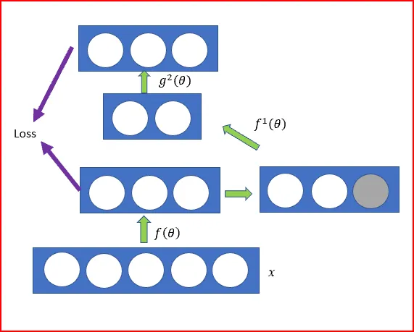

Stacked Autoencoders is a neural network with multiple layers of sparse autoencoders

When we add more hidden layers than just one hidden layer to an autoencoder, it helps to reduce a high dimensional data to a smaller code representing important features

Each hidden layer is a more compact representation than the last hidden layer

We can also denoise the input and then pass the data through the stacked autoencoders called as stacked denoising autoencoders

In Stacked Denoising Autoencoders, input corruption is used only for initial denoising. This helps learn important features present in the data. Once the mapping function f(θ) has been learnt. For further layers we use uncorrupted input from the previous layers.

After training a stack of encoders as explained above, we can use the output of the stacked denoising autoencoders as an input to a stand alone supervised machine learning like support vector machines or multi class logistics regression.

Deep Autoencoders

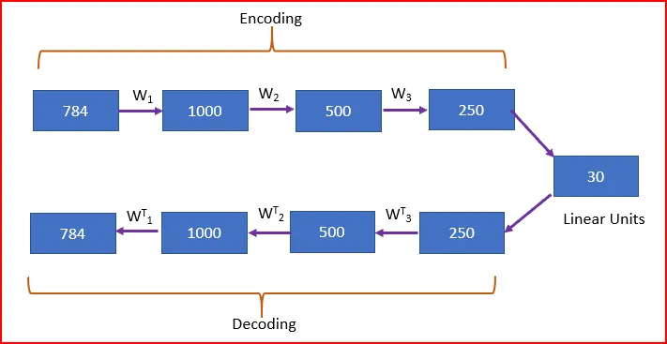

Deep Autoencoders consist of two identical deep belief networks. One network for encoding and another for decoding

Typically deep autoencoders have 4 to 5 layers for encoding and the next 4 to 5 layers for decoding. We use unsupervised layer by layer pre-training

Restricted Boltzmann Machine(RBM) is the basic building block of the deep belief network

In the above figure, we take an image with 784 pixel. Train using a stack of 4 RBMs, unroll them and then finetune with back propagation

Final encoding layer is compact and fast

|  |  |
| --- | --- |
|  | import numpy as np |
|  | import keras |
|  | from keras.datasets import mnist |
|  | from keras.models import Sequential, Model |
|  | from keras.layers import Dense, Input |
|  | from keras import optimizers |
|  | from keras.optimizers import Adam |
|  |  |
|  | (x_train, y_train), (x_test, y_test) = mnist.load_data() |
|  | train_x = x_train.reshape(60000, 784) / 255 |
|  | val_x = x_test.reshape(10000, 784) / 255 |
|  |  |
|  | autoencoder = Sequential() |
|  | autoencoder.add(Dense(512, activation='elu', input_shape=(784,))) |
|  | autoencoder.add(Dense(128, activation='elu')) |
|  | autoencoder.add(Dense(10, activation='linear', name="bottleneck")) |
|  | autoencoder.add(Dense(128, activation='elu')) |
|  | autoencoder.add(Dense(512, activation='elu')) |
|  | autoencoder.add(Dense(784, activation='sigmoid')) |
|  | autoencoder.compile(loss='mean_squared_error', optimizer = Adam()) |
|  | trained_model = autoencoder.fit(train_x, train_x, batch_size=1024, epochs=10, verbose=1, validation_data=(val_x, val_x)) |
|  | encoder = Model(autoencoder.input, autoencoder.get_layer('bottleneck').output) |
|  | encoded_data = encoder.predict(train_x) # bottleneck representation |
|  | decoded_output = autoencoder.predict(train_x) # reconstruction |
|  | encoding_dim = 10 |
|  |  |
|  | # return the decoder |
|  | encoded_input = Input(shape=(encoding_dim,)) |
|  | decoder = autoencoder.layers[-3](encoded_input) |
|  | decoder = autoencoder.layers[-2](decoder) |
|  | decoder = autoencoder.layers[-1](decoder) |
|  | decoder = Model(encoded_input, decoder) |

Autoencoder is an unsupervised artificial neural network that learns how to efficiently compress and encode data then learns how to reconstruct the data back from the reduced encoded representation to a representation that is as close to the original input as possible.

The aim of an autoencoder is to learn a lower-dimensional representation (encoding) for a higher-dimensional data, typically for dimensionality reduction, by training the network to capture the most important parts of the input image.

Autoencoder, by design, reduces data dimensions by learning how to ignore the noise in the data.

Architecture:

1- Encoder: In which the model learns how to reduce the input dimensions and compress the input data into an encoded representation.

2- Bottleneck: In which the layer contains the compressed representation of the input data. This is the lowest possible dimensions of the input data.

3- Decoder: In which the model learns how to reconstruct the data from the encoded representation to be as close to the original input as possible.

**ENCODER: $h\left(x\right)=sigmoid(W*x+b)$**

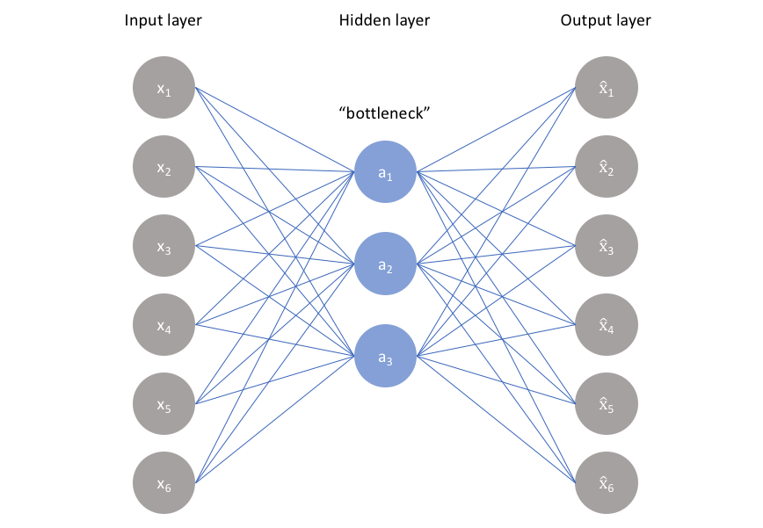

**DECODER: $\hat{x}=sigmoid(W^{*}*h(x)+c)$**

$$Loss Function=L\left(x,\hat{x}\right)+Regularization Term$$

**TIED WEIGHTS:** *Weights from input to hidden layer will be equal to the weights from hidden layer to output $W^{*}=W^{T}$*